**Experiments:**

The effects of using 50 (left image) vs. 100 (right image) tile columns on mosaic quality for color (top row) and grayscale (bottom row).

**Base Image Set:**

The following 20 base images were used for user testing. We divided the images into sets based on the subject(s) of the image, as we believed that users would have differing levels of success in recognizing the mosaics of these images based on their content.

**Set A: Highly Recognizable Entities, Single Subject in Photo, Simple Background**

This set includes photos of highly recognizable entities, such as famous people (ex. Barack Obama), objects (ex. Statue of Liberty), and organisms (ex. a cat). Each image only contained one subject, and the background was relatively simple. The correct descriptions for these images are very short and simple, ex. “Cat in a bag.” It was predicted that users would be able to easily recognize these entities from their mosaics.

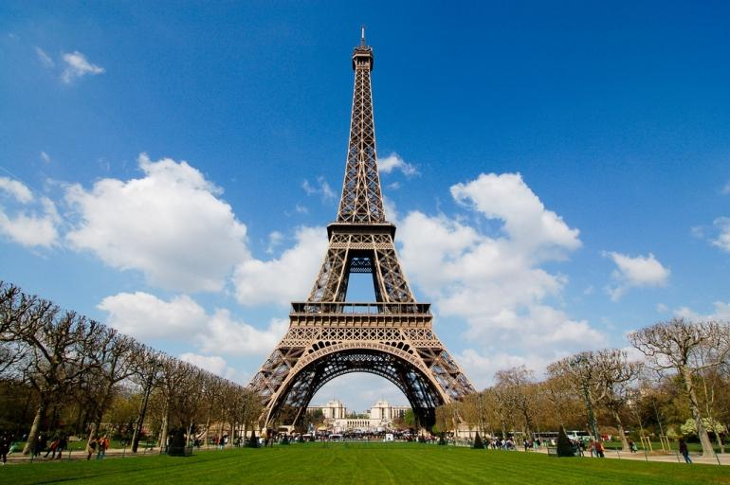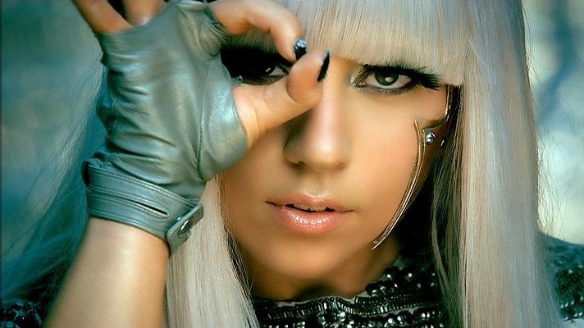

The mosaics for these images are shown below:

**Set B: Highly Recognizable Entities, Multiple Subjects in Photo, Simple Background**

To examine whether our system could handle more complicated photographs, this set includes highly recognizable entities, with multiple prominent subjects or objects in the base photo. The background was again simple and did not overly distract from the main subjects in the image. It was also predicted that users would have a relatively easy time recognizing theses subjects from their mosaics, or at least provide a reasonable description (ex. “a woman and a man getting married.”

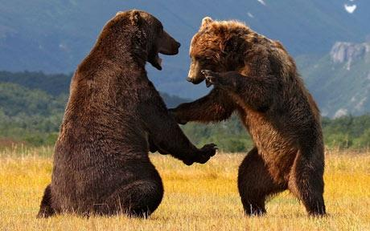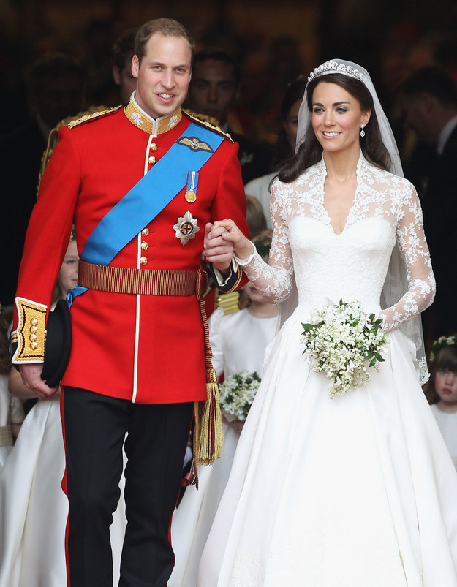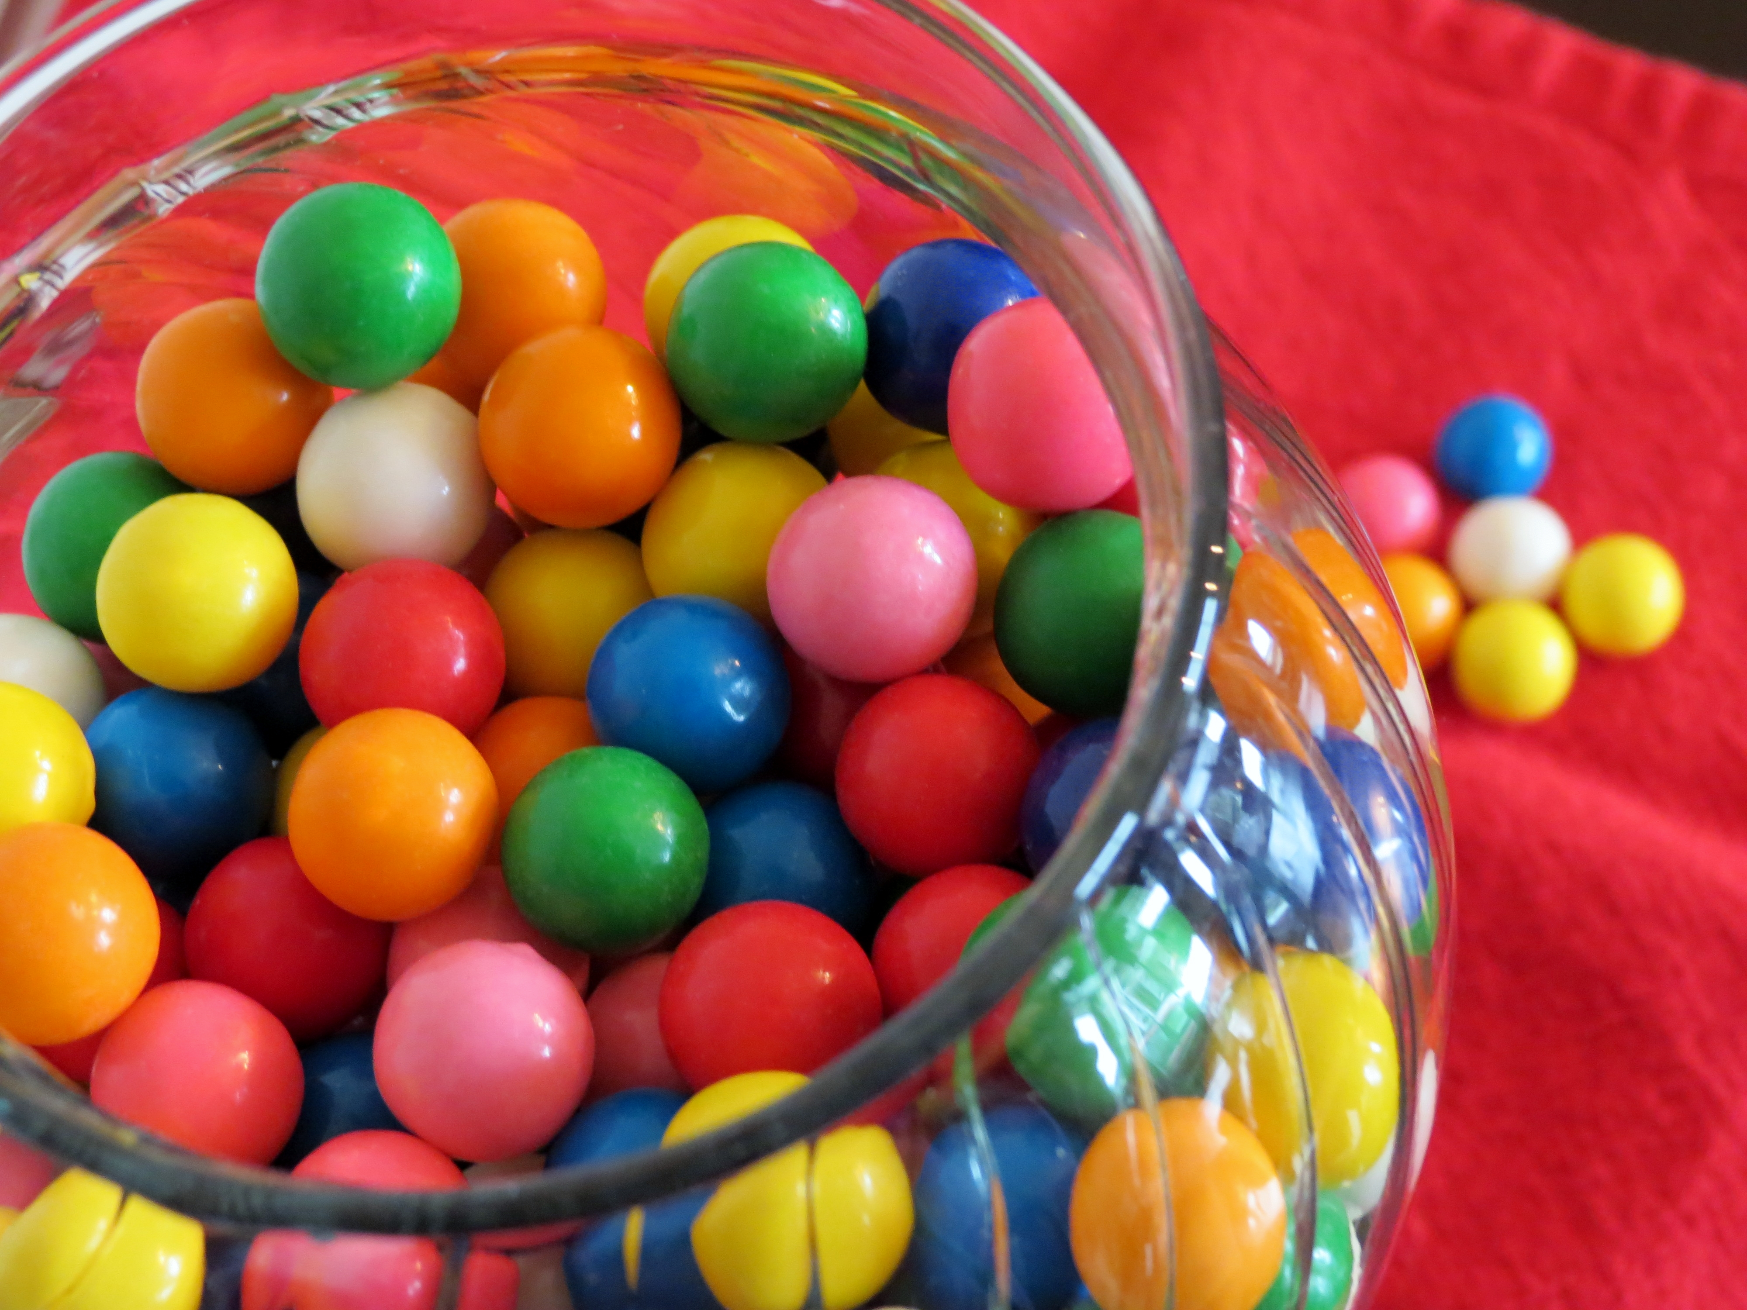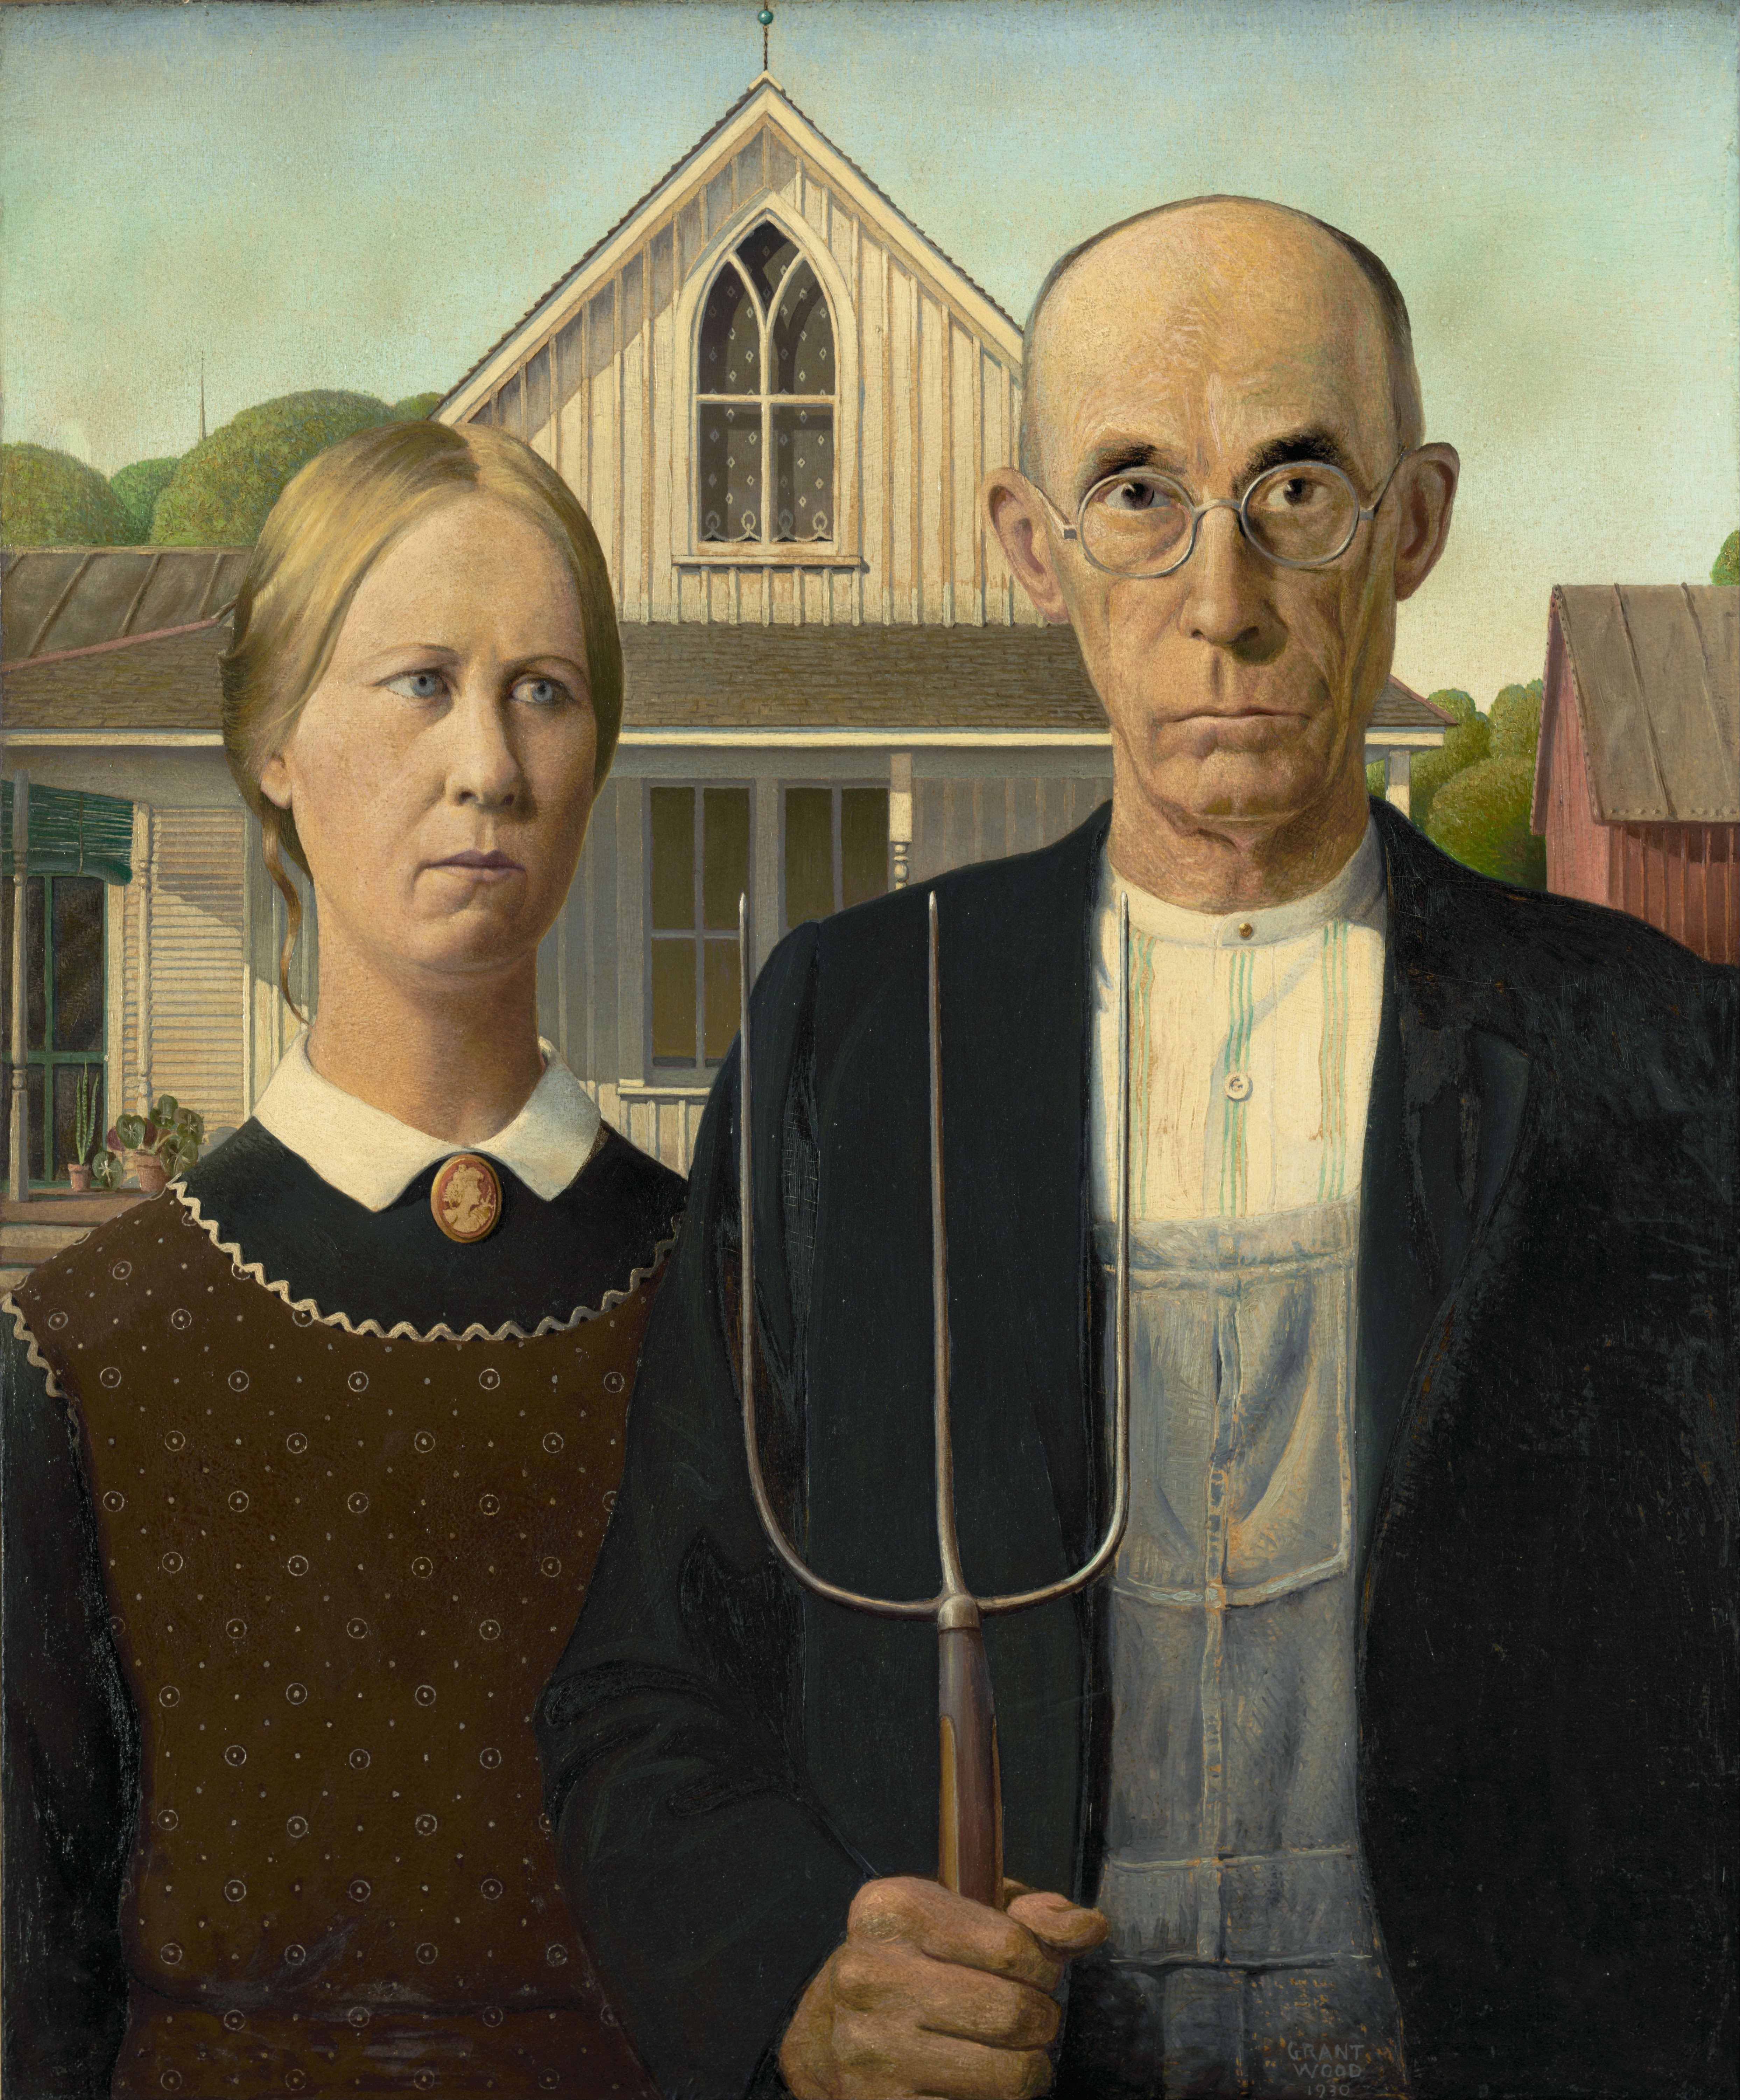

**Set C: Less Recognizable Entities, More Prominent and Complex Backgrounds**

The subject(s) is/are not necessarily famous (might be a generic stock photo model), and the background may have a more prominent presence in the picture compared to before. The correct descriptions for these images are also more complicated compared to Sets A and B, ex. “Woman doing yoga in the mountains.” We predicted that users would have a moderate to difficult time identifying the content of the mosaics.

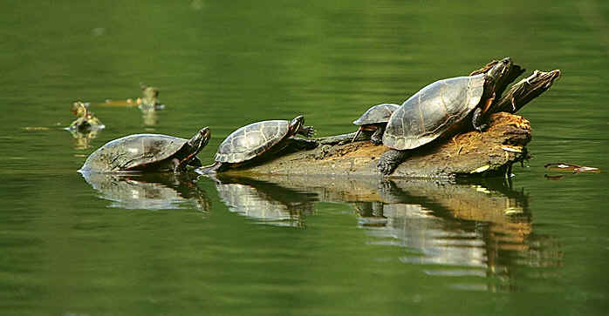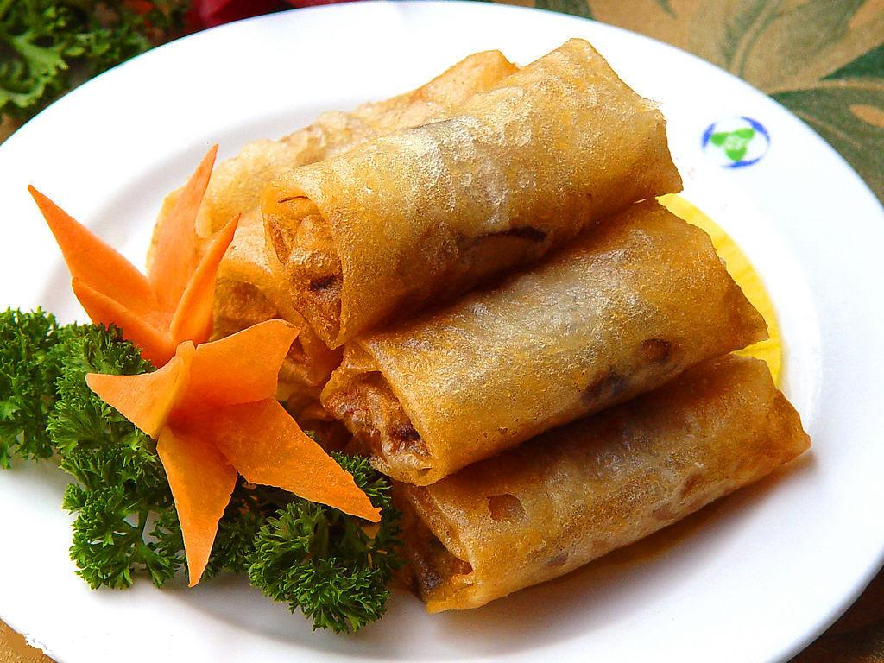

Set D:

**Set D: Complex Scenes**

Includes more complex scenes such as scenes with dynamic movement, elaborate backgrounds, and/or photos with many subjects in them. We predicted that users would have a lot of trouble identifying the content of these mosaics.

